Snow Plough Rubbers
We Manufacture & stock snow plough blades in Rubber & Polyurethane
We supply a wide range of snow plough rubber and slurry scraper blades in non standard sizes.
We can supply snow plough rubber in bespoke sizes.
Snow plough blades and scraper blades are manufactured in our own factory by our highly trained staff. We have an unrivalled level of experience and use the highest quality materials in our manufacturing process. The grade of rubbers & Polyurethanes we supply is ideally suited for use in all snow plough and slurry scraping applications.
For custom manufactured snow plough blades or scraping blades our team will work with you through the design stage, type approval and through to manufacture.
We do not specify minimum order quantities and can supply in small lots or pallet loads

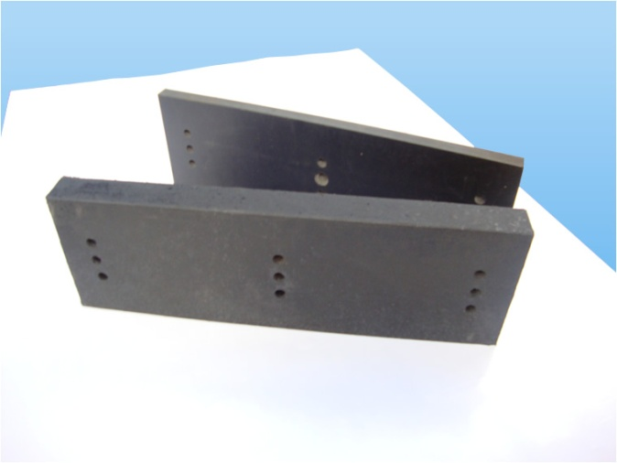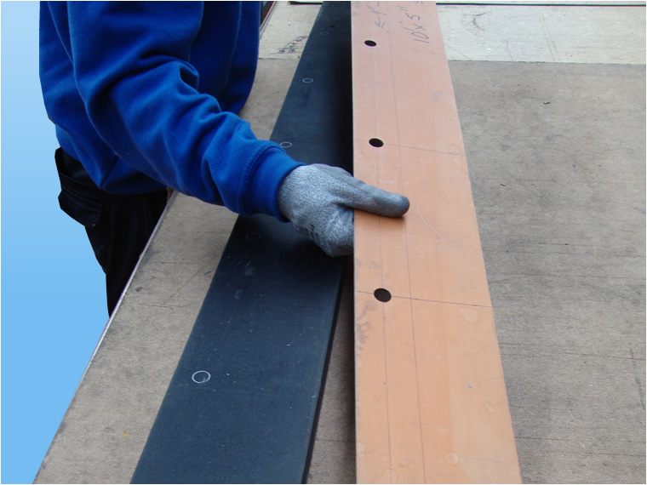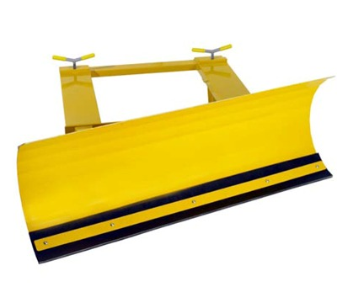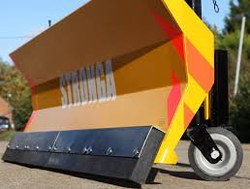
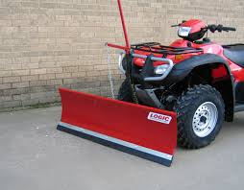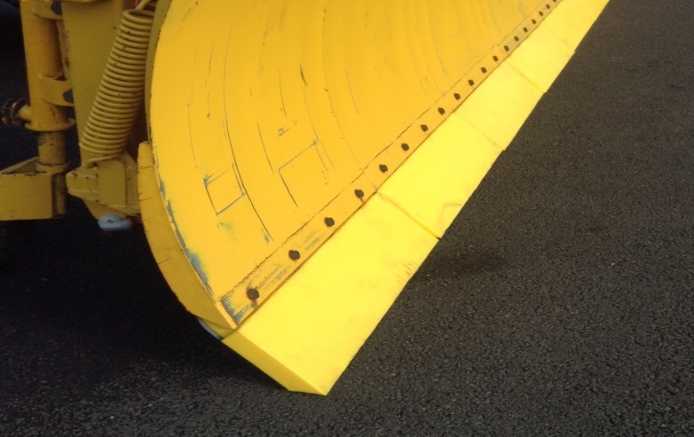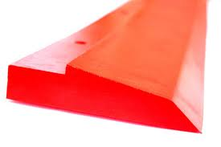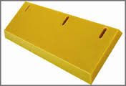

Customers , Logic , Stronga ,Newcastle Airport , Gateshead Council.

